Chapter 1
Key Concepts
Web Development & Design Foundations with XHTML
The Evolutionof the Internet
- Internet
  - Interconnected network of computer networks
  - ARPAnet
    - Advanced Research Project Agency
    - 1969 – four computers connected
  - NSFnet
    - National Science Foundation
  - Use of the Internet was originally limited to government, research and academic use
  - 1991 Commercial ban lifted
- Intranet
  - A private network contained within an organization or business used to share information and resources among coworkers.
- Extranet
  - A private network that securely shares part of an organization’s information or operations with external partners
The World Wide Web
The graphical user interface to information stored on some of the computers connected to the Internet
Internet Standards & Coordination
- The Internet Society
  - A professional organization that provides leadership in addressing issues related to the future of the Internet
  - IETF-- Internet Engineering Task Force
    - RFC – Requests for Comments
  - IAB – Internet Architecture Board

- ICANN - The Internet Corporation for Assigned Numbers & Names
  - Non-profit organization
  - Main function is to coordinate the assignment of:
    - Internet domain names
    - IP address numbers
    - Protocol parameters
    - Protocol port numbers.

Web Standards and the W3C Consortium
- W3C – World Wide Web Consortium
  - Develops recommendations and prototype technologies related to the Web
  - Produces specifications, called Recommendations, in an effort to standardize web technologies
  - WAI – Web Accessibility Initiative
Web Accessibility
- WAI – Web Accessibility Initiative
  - Develops recommendations for
    - web content developers,
    - web authoring tool developers,
    - developers of web browsers, and
    - developers of other user agents to facilitate use of the web by those with special needs.
  - WCAG
    - Web Content Accessibility Guidelines
http://www.w3.org/WAI/WCAG20/quickref/
- Section 508 of the Rehabilitation Act
  - requires that government agencies must give individuals with disabilities access to information technology that is comparable to the access available to others
Network Overview
- Network -- two or more computers connected together for the purpose of communicating and sharing resources
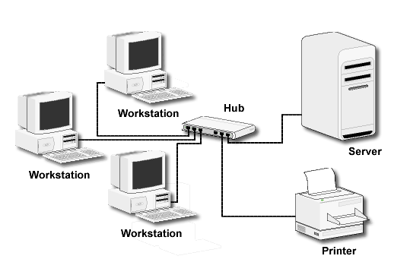
- LAN -- Local Area Network
  - Usually confined to a single building or group of buildings
- MAN -- Metropolitan Area Network
  - Connects computer resources in a local geographical area
- WAN -- Wide Area Network
  - Usually uses some form of public or commercial communications network to connect computers is widely dispersed geographical areas.

The Client/Server Model
- Client/Server can describe a relationship between two computer programs – the "client" and the "server".
- Client
  - requests some type of service (such as a file or database access) from the server.
- Server
  - fulfills the request and transmits the results to the client over a network
- The Internet Client/Server Model
  - Client -- Web Browser
  - Server -- Web Server
Web Client
- Connected to the Internet when needed
- Usually runs web browser (client) software such as Internet Explorer or Netscape
- Uses HTTP (Hypertext Transfer Protocol)
- Requests web pages from server
- Receives web pages and files from server
Web Server
- Continually connected to the Internet
- Runs web server software (such as Apache or Internet Information Server)
- Uses HTTP (Hypertext Transfer Protocol)
- Receives request for the web page
- Responds to request and transmits status code, web page, and associated files

MIME Type
- Multi-Purpose Internet Mail Extension
  - a set of rules that allow
multimedia documents
to be exchanged among
many different computer systems
Internet Protocols
- Protocols
  - Rules that describe the methods used for clients and servers to communicate with each other over a network.
  - There is no single protocol that makes the Internet and Web work.
- A number of protocols with specific functions are needed.
FTP File Transfer Protocol
- A set of rules that allow files to be exchanged between computers on the Internet.
- Web developers commonly use FTP to transfer web page files from their computers to web servers.
- FTP is also used to download programs and files from other servers to individual computers.
E-mail Protocols
- Sending E-mail
  - SMTP Simple Mail Transfer Protocol
- Receiving E-mail
  - POP (POP3) Post Office Protocol
  - IMAP Internet Mail Access Protocol
HTTPHypertext Transfer Protocol
- A set of rules for exchanging files such as text, graphic images, sound, video, and other multimedia files on the Web.
- Web browsers send HTTP requests for web pages and their associated files.
- Web servers send HTTP responses back to the web browsers.
TCP/IP Transmission Control Protocol/Internet Protocol
- TCP/IP has been adopted as the official communication protocol of the Internet.
- TCP and IP have different functions that work together to ensure reliable communication over the Internet.
- Purpose is to ensure the integrity of communication
- Breaks files and messages into individual units called packets

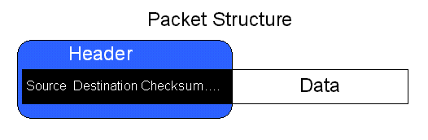
IP Internet Protocol
- A set of rules that controls how data is sent between computers on the Internet.
- IP routes a packet to the correct destination address.
The packet gets successively forwarded to the next closest router (a hardware device designed to move network traffic) until it reaches its destination.
IP Address
- Each device connected to the Internet has a unique numeric IP address.
- These addresses consist of a set of four groups of numbers, called octets.
64.233.167.99 will get you Google!
- An IP address may correspond to a domain name.

Domain Name
- Locates an organization or other entity on the Internet
- Domain Name System
  - Divides the Internet into logical groups and understandable names
  - Associates unique computer IP Addresses with the text-based domain names you type into a web browser
  - Browser: http://google.com
DNS: 64.233.187.9
URL Uniform Resource Locator
- URL
Represents the address of a resource on the Internet.

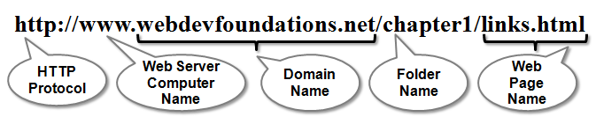
TLD Top-Level Domain Name
- A top-level domain (TLD) identifies the right-most part of the domain name.
- Current generic TLDs:
.com, .org, .net, .mil, .gov, .edu, .int, .aero, .asia, .cat, .jobs, .name, .biz, .museum, .info, .coop, .pro, .travel

County Code TLDs
- Two character codes originally intended to indicate the geographical location (country) of the web site.
- In practice, it is fairly easy to obtain a domain name with a country code TLD that is not local to the registrant.
- Examples:
  - .tv, .ws, .au, .jp, .uk

Domain Name System
- The Domain Name System (DNS) associates Domain Names with IP addresses.
- Each time a new URL is typed into a web browser:
  - 1.The DNS is accessed
  - 2.The corresponding IP address is obtained and returned to the web Browser
  - 3.The web browser sends an HTTP request to the destination computer with the corresponding IP address
  - 4.The HTTP request is received by the web server
  - 5.The necessary files are located and sent by HTTP responses to the web browser
  - 6.The web browser renders and displays the web page and associated files

Markup
Languages
- SGML – Standard Generalized Markup Language
  - A standard for specifying a markup language or tag set
- HTML – Hypertext Markup Language
  - The set of markup symbols or codes placed in a file intended for display on a web browser.

- XML – eXtensible Markup Language
  - A text-based language designed to describe, deliver, and exchange structured information.
  - It is not intended to replace HTML –
it is intended to extend the power of HTML by separating data from presentation.

- XHTML – eXtensible Hypertext Markup Language
  - Developed by the W3C as the reformulation of HTML 4.0 as an application of XML.
  - It combines the formatting strengths of HTML 4.0 and the data structure and extensibility strengths of XML.

- HTML 5
- The next version of HTML 4 and XHTML 1

- The relationship between
XHTML, HTML, and XML

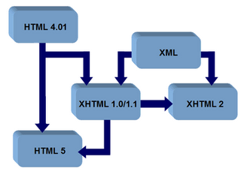

Chapter two
Web Development & Design Foundations with XHTML

What is
HTML?
- HTML:
The set of markup symbols or codes placed in a file intended for display on a Web browser page.
- The World Wide Web Consortium (http://w3c.org) sets the standards for HTML and its related languages.

HTML Elements
- Each individual markup code is referred to as an element or tag.
- Each tag has a purpose.
- Tags are enclosed in angle brackets, "<" and ">" symbols.
- Most tags come in pairs; an opening tag and a closing tag.

What is
XHTML?
- The newest version of HTML
- eXtensible HyperText Markup Language.
- XHTML uses:
  - the elements and attributes of HTML
  - the syntax of XML (eXtensible Markup Language).

XML Syntax
- An XML document must be well-formed.
  - Use lowercase
  - Use opening and closing tags
<body> </body>
  - Close stand-alone tag with special syntax
<hr />
- XML documents begin with an XML directive. The basic form of this directive is:
<?xml version="1.0" encoding="UTF-8"?>

Document
Type Definition (DTD)
- W3C Recommendation:
Use a Document Type Definition to identify the type of markup language used in a web page.

XHTML 1.0 Transitional
This is the least strict specification for XHTML 1.0. It allows the use of both Cascading Style Sheets and traditional formatting instructions such as fonts. We will use this DTD in this text
XHTML 1.0 Strict
Requires exclusive use of Cascading Style Sheets. We will not use this.
XHTML 1.0 Frameset
Required for pages using XHTML frames. We will use not use this.

Head & Body Sections
- Head Section
Contains information that describes the web page document
<head>
…head section info goes here
</head>
- Body Section
Contains text and elements that display in the Web page document
<body>
…body section info goes here
</body>

XHTML
<head> and <body> tags
<?xml version="1.0" encoding="UTF-8"?>
<!DOCTYPE html PUBLIC "-//W3C//DTD XHTML 1.0 Transitional//EN"
"http://www.w3.org/TR/xhtml1/DTD/xhtml1-transitional.dtd">
<html>
<head>
.... Header info goes here
</head>
<body>
.... Body info goes here
</body>
</html>

The Heading Element
<h1>Heading Level 1</h1>
<h2>Heading Level 2</h2>
<h3>Heading Level 3</h3>
<h4>Heading Level 4</h4>
<h5>Heading Level 5</h5>
<h6>Heading Level 6</h6>

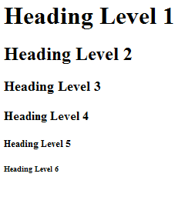
XHTML
<p> tag
- Paragraph element
<p> …paragraph goes here… </p>
  - Groups sentences and sections of text together.
  - Configures a blank line above and below the paragraph

XHTML
<br /> tag
- Line Break element
  - Stand-alone tag
…text goes here <br />
This starts on a new line….
  - Causes the next element or text to display on a new line

XHTML
<blockquote> tag
- Blockquote element
  - Indents a block of text for special emphasis
<blockquote>
…text goes here…
</blockquote>

XHTML List Basics
- Definition List
- Ordered List
- Unordered List

XHTML
Definition List
- Useful to display a list of terms and definitions or a list of FAQ and answers
  - <dl> tag
Contains the definition list
  - <dt> tag
Contains a defined term
Configures a line break above and below the text
<dd> tag
Contains a data definition or description
Indents the text
XHTML
Definition List Example
<dl>
<dt>IP</dt>
<dd>Internet Protocol</dd>
<dt>TCP</dt>
<dd>Transmission Control Protocol</dd>
</dl>

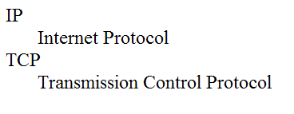
XHTML
Ordered List
- Conveys information in an ordered fashion
- <ol>
Contains the ordered list
  - type attribute determines numbering scheme of list, default is numerals
- <li>
Contains an item in the list

XHTML
Ordered List Example
<ol>
<li>Apply to school</li>
<li>Register for course</li>
<li>Pay tuition</li>
<li>Attend course</li>
</ol>

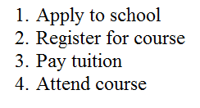
XHTML
Unordered List
- Displays information with bullet points
- <ul>
Contains the unordered list
  - type attribute determines the type of bullet point
  - default type is disc (but depends on the browser used)
- <li>
Contains an item in the list

XHTML
Unordered List Example
<ul>
<li>TCP</li>
<li>IP</li>
<li>HTTP</li>
<li>FTP</li>
</ul>

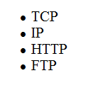
XHTML
Logical Style Elements
- Indicate the logical style of the text display
- Common Logical Style Tags
  - <strong></strong>
    - To cause text to be emphasized or to "stand out" from surrounding text.
<strong>This is important</strong>
  - <em></em>
    - To cause text to be emphasized in relation to other text on the page. Usually italics.
<em>Please note</em>
XHTML
Physical Style Elements
- Provide browser font configuration info
  - Useful for browsers – but not always applicable for other devices or user agents such as screen readers
- Common Physical Style Tags
  - <b></b>
    - To display as bold text
<b>This is important</b>
  - <i></i>
    - To display text in italics
<i>Please note</i>

XHTML
Special Characters
Display special characters such as quotes, copyright symbol, etc
Character Code
© &copy;
< &lt;
> &gt;
& &amp;
space &nbsp;
XHTML
<a> tag
- The anchor element
  - Specifies a hyperlink reference (href) to a file
  - Text between the <a> and </a> is displayed on the web page.
<a href="contact.html">Contact Us</a>
  - href Attribute
Indicates the file name or URL
Web page document, photo, pdf, etc.
XHTML
<a> tag
- Absolute link
  - Link to other Web sites
<a href="http://yahoo.com">Yahoo</a>
- Relative link
  - Link to pages on your own site
<a href="index.htm">Home</a>
Hyperlinks
- Hands-On Practice

XHTML Email Links
using the <a> tag
- Automatically launch the default mail program configured for the browser
- If no browser default is configured, a message is displayed
<a href=“mailto:me@hotmail.com”>me@hotmail.com</a>

Writing Valid XHTML
- Check your code for syntax errors
  - Benefit:
    - Valid code more consistent browser display
- W3C XHTML Validation Tool
  - http://validator.w3.org

Chapter 3
Key Concepts

Web Development & Design Foundations with XHTML
Overview of
Cascading Style Sheets (CSS)
- See what is possible with CSS:
  - Visit http://www.zengarden.com
- Style Sheets
  - used for years in Desktop Publishing
  - apply typographical styles and spacing to printed media
- CSS
  - provides the functionality of style sheets (and much more) for web developers
  - a flexible, cross-platform, standards-based language developed by the W3C.

CSS
Advantages
- Greater typography and page layout control
- Style is separate from structure
- Styles can be stored in a separate document and linked to from the web page
- Potentially smaller documents
- Easier site maintenance

Types of
Cascading Style Sheets (1)
- Inline Styles
- Embedded Styles
- External Styles
- Imported Styles

- Inline Styles
  - Configured in the body of the Web page
  - Use the style attribute of an XHTML tag
  - Apply only to the specific element
- Embedded Styles
  - Configured in the header section of a Web page.
  - Use the XHTML <style> element
  - Apply to the entire Web page document
- External Styles
  - Configured in a separate text file with .css file extension
  - The XHTML <link /> element in the header section of a Web page associates it with the .css file
- Imported Styles
  - Similar to External Styles
  - We’ll concentrate on the other three types of styles.

CSS
Syntax
- Style sheets are composed of "Rules" that describe the styling to be applied.
- Each Rule contains a Selector and a Declaration

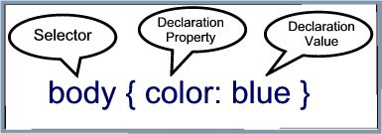
CSS
Syntax Sample
Configure a Web page to display blue text and yellow background.
body { color: blue;
background-color: yellow; }
This could also be written using hexadecimal color values as shown below.
body { color: #0000FF;
background-color: #FFFF00; }

Common Formatting
CSS Properties
- See Table 3.1 Common CSS Properties, including:
  - background-color
  - color
  - font-family
  - font-size
  - font-style
  - font-weight
  - line-height
  - margin
  - text-align
  - text-decoration
  - width

Using Color on
Web Pages
- Computer monitors display color as intensities of red, green, and blue light
- RGB Color
- The values of red, green, and blue vary from 0 to 255.
- Hexadecimal numbers (base 16) represent these color values.

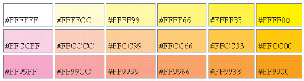
Hexadecimal
Color Values
- # is used to indicate a hexadecimal value
- Hex value pairs range from 00 to FF
- Three hex value pairs describe an RGB color
#000000 black #FFFFFF white
#FF0000 red #00FF00 green
#0000FF blue

Web Color
Palette
- A collection of 216 colors
- Display the most similar
on the Mac and PC
platforms
- Hex values:
00, 33, 66, 99, CC, FF

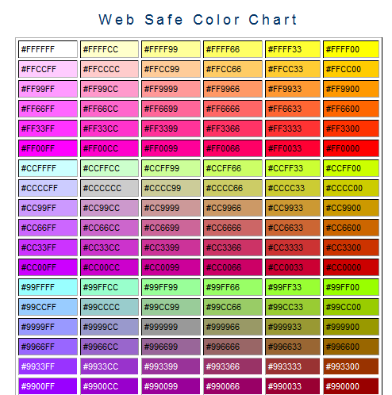
Making Color Choices
- How to choose a color scheme?
  - Monochromatic
    - http://meyerweb.com/eric/tools/color-blend
  - Choose from a photograph or other image
    - http://www.colr.org
  - Begin with a favorite color
    - Use one of the sites below to choose other colors
      - http://colorsontheweb.com/colorwizard.asp
      - http://kuler.Adobe.com
      - http://www.steeldolphin.com/color_scheme.html
      - http://wellstyled.com/tools/colorscheme2/index-en.html
      - http://www.colors4webmasters.com/safecolor/index.htm

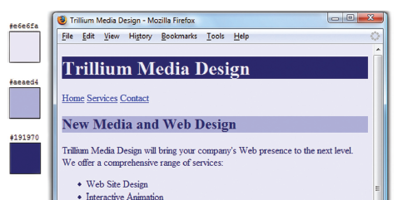
Accessibility & Color
- Everyone is not able to see or distinguish between colors
- Information must be conveyed even if color cannot be viewed
- According to Vischeck http://www.vischeck.com/vischeck
  - 1 out of 20 people experience some type of color deficiency
  - Color choice can be crucial
  - Avoid using red, green, brown, gray, or purple next to each other
  - White, black, and shades of blue and yellow are easier to differentiate.
- Simulation: http://www.vischeck.com/vischeck/vischeckURL.php

Configuring Color with Inline CSS (1)
- Inline CSS
  - Configured in the body of the Web page
  - Use the style attribute of an XHTML tag
  - Apply only to the specific element
  - The Style Attribute
  - Value: one or more style declaration property and value pairs

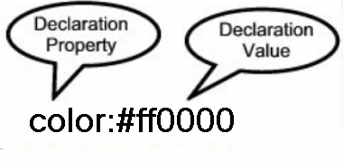
Example: configure red color text in an <h1> element:
<h1 style="color:#ff0000">Heading text is red</h1>
Example 2: configure the red text in the heading
configure a gray backgroundin the heading
Separate style rule declarations with ;
<h1 style="color:#FF0000;background-color:#cccccc">This is displayed as a red heading with gray background</h1>

CSS Embedded Styles
- Configured in the header section of a Web page.
- Use the XHTML <style> element
- Apply to the entire Web page document
- Style declarations are contained between the opening and closing <style> tags
- The type attribute indicates the MIME type of text/css
- Example: Configure a Web page with white text on a black background

<style type ="text/css">
body { background-color: #000000;
color: #FFFFFF;
}
</style>

- The body selector sets the global style rules for the entire page.
- These global rules are overridden for <h1> and <h2> elements by the h1 and h2 style rules.

- <style type="text/css">
- body { background-color: #E6E6FA;
- color: #191970;}
- h1 { background-color: #191970;
- color: #E6E6FA;}
- h2 { background-color: #AEAED4;
- color: #191970;}
- </style>

Configuring Text with CSS
- CSS properties for configuring text:
  - font-weight
    - Configures the boldness of text
  - font-style
    - Configures text to an italic style
  - font-size
    - Configures the size of the text
  - font-family
    - Configures the font typeface of the text

The font-size Property
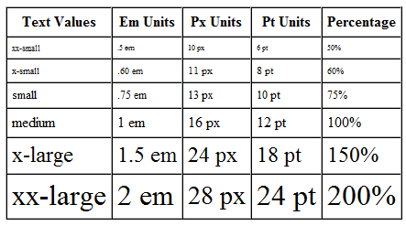
- Accessibility Recommendation:
  - Use em or percentage font sizes – these can be easily enlarged in all browsers by users

The font-family Property
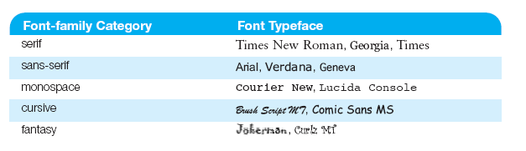
- Not everyone has the same fonts installed in their computer
- Configure a list of fonts and include a generic family name
p {font-family: Arial,Verdana, sans-serif;}

Embedded Styles Example
<style type="text/css">
body { background-color: #E6E6FA;
color: #191970;
font-family: Arial, Verdana, sans-serif; }
h1 { background-color: #191970;
color: #E6E6FA;
line-height: 200%;
font-family: Georgia, "Times New Roman", serif; }
h2 { background-color: #AEAED4;
color: #191970;
font-family: Georgia, "Times New Roman", serif; }
p {font-size: .90em; }
ul {font-weight: bold; }
</style>

CSS Selectors
CSS style rules can be configured for an:
  - HTML element selector
  - class selector
  - id selector

Using CSS
with “class”
- class Selector
  - Use to apply a CSS
rule to a certain
"class" of elements
on a Web page
  - Does not associate the
style to a particular
XHTML element

<style type="text/css">
.new { color: #FF0000;
font-style: italic;
}
</style>

- Configure with .classname
- The sample creates a class called “new” with red italic text.
- To use the class, code the following XHTML:
<p class=“new”>This is text is red and in italics</p>

Using CSS
with “id”
- id Selector
  - Use to apply a CSS
rule to ONE element
on a Web page.
- Configure with #idname

<style type="text/css">
#new { color: #FF0000;
font-size:2em;
font-style: italic;
}
</style>

- The sample creates an id called “new” with red, large, italic text.
- To use the id, code the following XHTML:
<p id=“new”>This is text is red, large, and in italics</p>

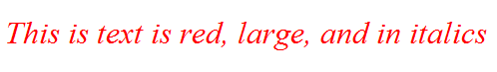
XHTML
<div> element
- A block-level element
- Purpose: configure a specially formatted division or area of a Web page
  - There is a line break before and after the division.
  - Can contain other block-level and inline elements
  - Useful to define an area that will contain other block-level tags (such as paragraphs or spans) within it.

XHTML
<div> Element Example
- Configure a page footer area
Embedded CSS:
<style type="text/css">
.footer { font-size: small;
text-align: center; }
</style>
- XHTML:

<div class=“footer">Copyright &copy; 2009</div>

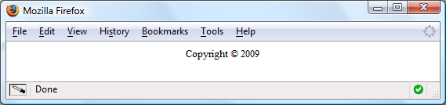
XHTML
<span> element
- An inline-level element
- Purpose:
  - configure a specially formatted area displayed in-line with other elements, such as within a paragraph.
- There is no line break before and after the span.

XHTML
<span> Element Example
Embedded CSS:
<style type="text/css">
.companyname { font-weight: bold;
font-family: Georgia, "Times New Roman", serif;
font-size: 1.25em;
}
</style>
- XHTML:

<p>Your needs are important to us at <span class=“companyname">Acme Web Design</span>.
We will work with you to build your Web site.</p>

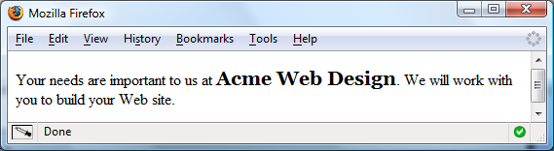
External
Style Sheets – 1
- CSS style rules are contained in a text file separate from the XHTML documents.
- The External Style Sheet text file:
  - extension ".css"
  - contains only style rules
  - does not contain any XHTML tags

  - Multiple web pages can associate with the same external style sheet file.

body {background-color:#E6E6FA;
color:#000000;
font-family:Arial, sans-serif;
font-size:90%; }
h2 { color: #003366; }
.nav { font-size: 16px;
font-weight: bold; }

The <link /> Element
- A self-contained tag
- Placed in the header section
- Purpose: associates the external style sheet file with the web page.
- Example:

<link rel="stylesheet" href="color.css" type="text/css" />

Using an
External Style Sheet
External Style Sheet color.css

body { background-color: #0000FF;
color: #FFFFFF;
}

To link to the external style sheet called color.css, the XHTML code placed in the header section is:
<link rel="stylesheet" href="color.css" type="text/css" />

Centering Page Content
with CSS
#container { margin-left: auto;
margin-right: auto;
width:80%; }

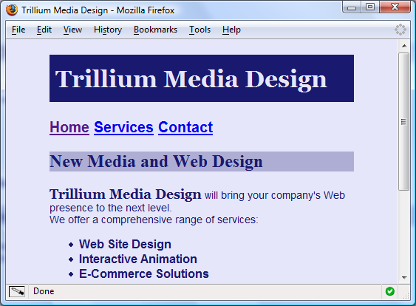
W3C CSS Validation
- http://jigsaw.w3.org/css-validator/

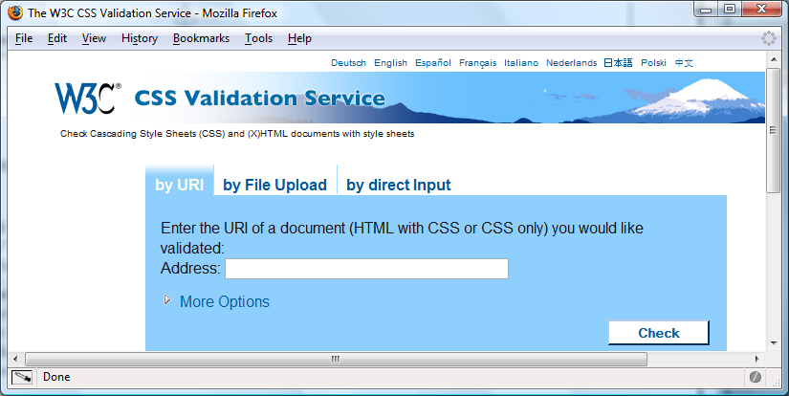
CSS Guidelines –
Getting Started
- Review the design of the page
  - Configure global font and color properties for the body selector
  - Identify typical elements (such as <h1>, <h3>, and so on) and declare style rules for these if needed.
  - Identify page areas such as logo, navigation, footer, and so on – configure an appropriate class or id for each.
- Create one prototype page that contains most of the elements you plan to use and test.
  - Revise your CSS as needed.
  - Once your design is set – move styles to an external .css file
- Planning and testing are important activities when designing a Web site

CSS Troubleshooting Tips
- Verify you are using the : and ; symbols in the right spots—they are easy to confuse.
- Check that you are not using = signs instead of : between each property and its value.
- Verify that the { and } symbols are properly placed
- Check the syntax of your selectors, their properties, and property values for correct usage.
- If part of your CSS works, and part doesn’t:
  - Review your CSS
  - Determine the first rule that is not applied.
Often the error is in the rule above the rule that is not applied.
Validate your CSS at http://jigsaw.w3.org/css-validator

